The English
Language
Learner (ELL) Parent Guide
This is how we define student success:
By never giving up and never giving in, every learner realizes individual excellence socially, emotionally, and academically.
Johnstown-Monroe School District
Where Student Success is Everything!

Purpose
The purpose Title III of the Every Student Succeeds Act is to help meet the needs of Limited English Proficient students, develop high quality language instruction programs, build agencies’ capacities, promote parental involvement, streamline programs, hold state and local educational agencies accountable, and provide flexibility for agencies. For more information visit Ohio Department of Education: Every Student Succeeds Act (ESSA)
For more information regarding English Learners visit Ohio Department of Education: Profile of Ohio English Learners.

What is an ELL?
•Federal law defines a "limited English proficient" student as a student:
1) is aged 3 through 21;
2) is enrolled or preparing to enroll in an elementary school or secondary school;
3) meets one of the following criteria—
a) was not born in the United States, or whose native language is a language other than English;
b) is a Native American or Alaska Native, or a native resident of the outlying areas; and comes from an environment where a language other than English has had a significant impact on the individual's level of English language proficiency (ELP); or
c) is migratory, whose native language is a language other than English, and who comes from an environment where a language other than English is dominant—and
4) has difficulties in speaking, reading, writing, or understanding the English language, that may be sufficient to deny the individual
a) the ability to meet the challenging state academic standards;
b) the ability to successfully achieve in classrooms where the language of instruction is English; or
c) the opportunity to participate fully in society.
•In Ohio:
A “limited English proficient student” is a student who is aged three through 21; is enrolled or preparing to enroll in an elementary or secondary school; whose native language is a language other than English, or a native American or migrant who comes from an environment where another language has had a significant impact on the student's English proficiency; and whose difficulties speaking, reading, writing, or understanding English may deny the student to meet the proficient level of achievement on proficiency or achievement tests, the ability to achieve successfully in classrooms where the language of instruction is English, or the opportunity to participate fully in society.

Program description
Johnstown-Monroe Local Schools ELL program offers:

Small Group Instruction for English Learning (EL)
Limited English proficient students are directly instructed in the use of the English language. Instruction is based on a special curriculum that typically involves little or no use of the students’ native language and is usually taught during specific school periods. For the remainder of the school day, students may be placed in mainstream classrooms. EL classes may focus on teaching formal English grammar and on promoting natural communication activities (free conversation, games, discussions on familiar topics). Reading and writing are practiced as well as oral communication skills in English.
In-class Support
In this approach, LEP students are together with their native-English speaking peers in the same classroom, but an EL specialist is available in the classroom to support the LEP students. For example, the EL specialist may provide guidance to the LEP students as they are working on a group project or individual assignment.
Newcomer Support
Newcomer programs are programs designed for recent immigrants at the secondary school level who have little or no English proficiency, and limited or no formal education in their native countries. These programs have been developed to meet newcomers' needs before they enter into general education classrooms.
Consultation, Monitoring and Academic Assistance
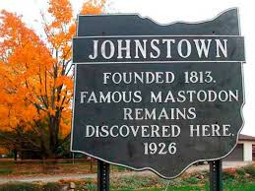
To assure that former English learners are successful in academics through effective instruction and accessible programs, Ohio schools and districts are required to monitor former English learners for at least two years after students exit from the English learner program. During the monitoring process, schools and districts develop procedures based upon best practice to support Former English Learners (FEL). That is, schools and districts make certain that former English learners have not been prematurely exited from the English language program and are able to access the general education curriculum without supplementary linguistic supports.

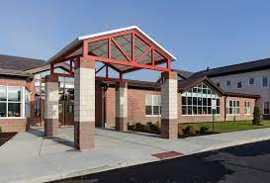
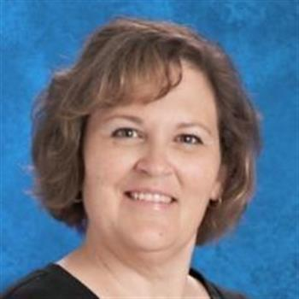  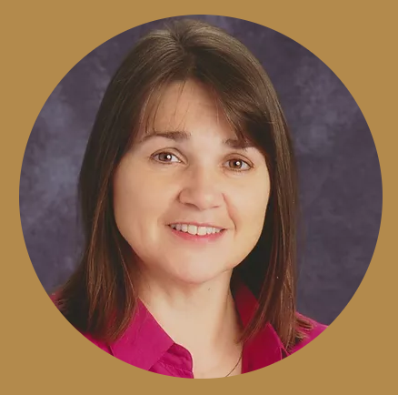 | ELL Staff  LORI DILL COHEN  English Language Learner Teacher  This is Mrs. Cohen’s 8th year of teaching in public & private schools.  Otterbein University  Master of Arts in Education in Curriculum & Instruction, TESOL strand  The Ohio State University, Columbus, Ohio  Bachelor of Music Education  Email: lcohen@jmk12.org, 614-304-1732 (text in any language)  amy schulze  Educational Paraprofessional  Mrs. Schulze has been employed with the Johnstown Monroe Local School District for 9 years.  Ohio Dominican University  Degree in International Business, Minor in Spanish  Studied Abroad in Spain  Spanish Language Immersion  Email: aschulze@jmk12.org  Parenting Resources:  INFOhio Parent Resources  ● So You’re Parenting a Kindergartner: English version | en Español  ● So You’re Parenting a First Grader: English version | en Español  ● So You’re Parenting a Second Grader: English version | en Español  ● So You’re Parenting a Third Grader: English version | en Español  INFOhio information on Beginning Readers.  INFOhio preK-12 digital library of resources to help students.

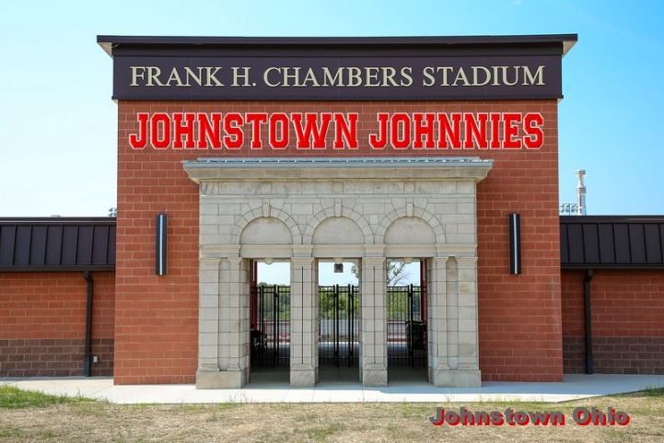
Assessment and placement

Under Title III, part A of the Elementary and Secondary Education Act , there are three
assessment requirements for English Learner (EL) Students:
1. Test to determine language skills.
2. Yearly language test to measure development and progress of English proficiency.
3. Testing to measure students’ progress in meeting State learning goals.

The following information is published by Ohio Department of Education. The current revision is dated April 2018. GUIDELINES FOR THE IDENTIFICATION OF ENGLISH LEARNERS, 2022
(Click here) https://education.ohio.gov/Topics/Student-Supports/English-Learners/Teaching-English-Learners/Guidelines-for-Identifying-English-Learners
Identifying English Learners in Ohio
School districts and community schools have a responsibility to identify English learners so they can provide instruction designed to help them use the English language and learn subject matter content. This document describes the two-step process for identifying English learners in Ohio. These guidelines are effective beginning with the 2018-2019 school year
Schools must complete this process and notify parents or guardians of the student’s identification as an English learner within 30 days of enrollment at the beginning of the school year or within two weeks of enrollment during the school year.

Step 1: Language Usage Survey
Schools must identify students who are English learners within 30 days of the student's enrollment. As part of welcoming new students and their families, Ohio’s Language Usage Survey must be completed for each student, in collaboration with parents and families, to support the identification and instruction of potential English learners and the provision of understandable communications.

Step 2: Ohio English Language Proficiency Screener
The OELPS is the standardized assessment tool the Department uses to classify students as English learners. When students are identified as potential English learners, they take the Ohio English Language Proficiency Screener (OELPS) to gauge their development of English as a second or new language in the domains of listening, speaking, reading and writing.

More information about the 2-step process can be found in the document Identifying English Learners in Ohio. This guide provides information for school staff to administer and communicate about the process of identifying and serving English learners. Translations of the Language Usage Survey (Appendix A) are available below. Please see supplemental questions (Appendix B) for assistance in gathering additional information to better understand and serve students and families with limited English proficiency.

Next Steps
Notify parents of English learner identification and services. If a student is identified as an English learner, the district or school must notify parent(s) or guardian(s) explaining the child’s classification as an English learner and the available services. Information about the Letters to Parents of Students Identified as English Learners is available in this manual.
Implement language assistance services. After a district or school has identified English learners with the language usage survey and English language proficiency screener, it must determine and implement the language instruction educational program the student will receive. Guidelines and information about programmatic options for English learners are available in this manual.
Annually assess all English learners. State and federal law require an annual assessment of K-12 students identified as English learners to measure their English language proficiency. In Ohio, this is the Ohio English Language Proficiency Assessment (OELPA). Visit the OELPA website for more information.

OELPA OVERALL PERFORMANCE LEVELS
1 - Emerging | 2 - Progressing | 3 - Proficient
Any score combination of 1s and 2s across all nonexempt domains. | Any combination of scores across the nonexempt domains that is not Proficient or Emerging. | Any score combination of 4s and 5s across all nonexempt domains.
Student continues as an English learner. | Student continues as an English learner. | Student exits from English learner status.

Exit Criteria
Only students, including those with documented domain exemptions, who achieve an overall performance level of Proficient on the OELPA exit from English learner status. The overall performance level of Proficient is defined as domain scores of 4s and 5s in any combination across all nonexempt domain tests (listening, reading, writing and speaking). For students who achieve a proficiency status of Progressing or Emerging, schools will determine and provide the appropriate services to ensure students’ development of English language proficiency and access to the curriculum. Untested and invalidated domains are considered 1s for this purpose, so students who did not attempt one or more test domains in the absence of a valid exemption or had one or more test domains invalidated cannot achieve an overall performance level of Proficient. These students will be considered Progressing or Emerging depending on their performances on the scored domains.
Family Engagement & Communication  Photo courtesy Ty Wright/The Advocate | Interpreters  Johnstown-Monroe Schools provides interpreters for important events and parent/teacher conferences. Please indicate if you would like a translator to assist in a school related conference or meeting.
Translated Documents
Johnstown-Monroe Schools makes every effort to translate school documents for families who prefer documents in their home langauge. Please indicate if you would like certain documents translated in your home language.

Communication
Johnstown-Monroe teachers encourage open communication with families. Please indicate how you would prefer communications home about students. English Language Learner teachers can also assist in message delivery and translation.

Appendix
- All families fill out the Ohio Department of Education’s Language Usage Survey upon registration in the school district.
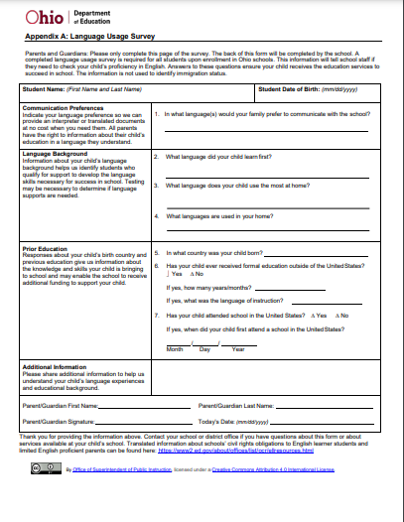

- Arabic: Word | PDF
- Chinese: Word | PDF
- Creole French: Word | PDF
- English: PDF
- French: Word | PDF
- German: Word | PDF
- Japanese: Word | PDF
- Nepali: Word | PDF

- Portuguese: Word | PDF
- Russian: Word | PDF
- Somali: Word | PDF
- Spanish US: Word | PDF
- Swahili: Word | PDF
- Turkish: Word | PDF
- Twi: Word | PDF
- Vietnamese: Word | PDF

- The importance of proficient language in the workplace.
